

**Graded Lab Assignment 3 – CSF416_Web Technologies and Applications, ODD Sem, 2024**

# Student Name: Muskan Kumari ID: 1000016871 Major: B.tech IT

**Instructions**

* There are **2** questions in this assignment.
* Email/paper/other modes of submissions will not be accepted.
* Upload a word **version** of this document.
* Assignment submitted after due date will not be evaluated and a score of zero will be awarded.
* Plagiarism may lead to award of zero marks.

**Due Date: 5pm, 4th November 2024**

**Submitting this Assignment**

You will submit (upload) this assignment in MS Teams. Name this document as GLA1_AJPODD2024_John_Doe.doc in case your name is John Doe, and this graded lab assignment is 1 of course whose acronym is AJP, and offered in ODD 2024. Paste your code after each question, paste the screenshot of output, save and upload the document.

**Grading Scheme:** This assignment has5 marks.

**Question 1:**

**Cookie Expiration Example**

* Write a servlet that creates a temporary cookie (expires in 1 minute).
* Display a message indicating whether the cookie is present or has expired each time the page is visited.

public class CookieServlet extends HttpServlet { private static final long serialVersionUID = 1L;

protected void doGet(HttpServletRequest request, HttpServletResponse response) throws ServletException, IOException { response.setContentType("text/html");

PrintWriter out = response.getWriter(); Cookie[] cookies = request.getCookies(); boolean cookieExists = false;

if (cookies != null) { for (Cookie cookie : cookies) {

if ("tempCookie".equals(cookie.getName())) {

cookieExists = true;

break;

}

}

}

if (!cookieExists) {

Cookie tempCookie = new Cookie("tempCookie", "temporaryValue"); tempCookie.setMaxAge(60); // Set expiration time to 60 seconds (1 minute) response.addCookie(tempCookie);

out.println("<h2>Temporary cookie created. It will expire in 1 minute.</h2>");

} else {

out.println("<h2>Welcome back! Your cookie is still active.</h2>");

}

out.println("<p>Refresh the page to see if the cookie has expired.</p>"); out.close();

}

}

# OUTPUT

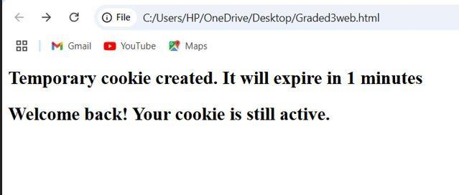

**Question 2:**

**Logout Feature with Session Invalidation**

* Create a simple login and logout system with JSP and servlets.
* Use session attributes to track if a user is logged in.
* Provide a logout option that invalidates the session and redirects the user to the login page.

<!DOCTYPE html>

<html>

<head>

<title>Login</title>

</head>

<body>

<h2>Login</h2>

<form action="LoginServlet" method="post">

Username: <input type="text" name="username" required><br>

Password: <input type="password" name="password" required><br>

<input type="submit" value="Login">

</form>

<p style="color:red;">Invalid username or password!</p>

</body>

</html>

# OUTPUT

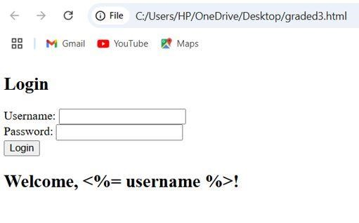

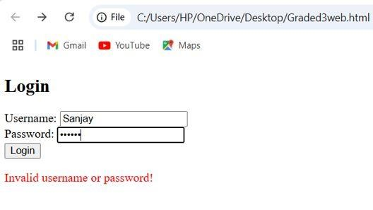

<!DOCTYPE html>

<html>

<head>

<title>Home</title>

</head>

<body>

<h2>Welcome, <%= session.getAttribute("username") %>!</h2>

<a href="LogoutServlet">Logout</a>

</body>

</html>

# OUTPUT

